TITLE
HaptiSense Vest: A Wearable Obstacle Detection System with Distance-Based Haptic Feedback for Visually Impaired Users

AUTHORS

Muhammad Hariz bin Helmi Shamsul (2316441), Muhammad Aiman Alfaruq bin Noredan (2316963), Wan Syazmie Akmal bin Wan Saad (2316957), Department Of Mechatronics Engineering, International Islamic University Malaysia,
Email: muhammadharizhelmishamsul@gmail.com

ABSTRACT

This paper presents the development of HaptiSense Vest: A Wearable Obstacle Detection System with Distance-Based Haptic Feedback to assist visually impaired users in safe navigation. The system utilizes a dual-microcontroller architecture in which an ESP32 performs real-time distance measurement using a TF-Luna LiDAR sensor, while an Arduino UNO controls vibration motors and a buzzer through an L298P motor driver. Obstacle proximity is conveyed through multi-level vibration feedback, enabling intuitive distance awareness without relying on visual or audio cues. A facial recognition module using the HuskyLens AI vision sensor is integrated to enhance system security by distinguishing authorized and unauthorized users via distinct buzzer alerts. Experimental evaluation demonstrates fast system response and reliable haptic feedback suitable for real-time operation. The proposed wearable system provides a compact, low-cost, and effective assistive solution that enhances user safety, independence, and situational awareness.

1. INTRODUCTION

Wearable obstacle detection systems have been developed to improve the mobility and safety of visually impaired individuals. Early wearable systems mainly utilized ultrasonic sensors to detect obstacles and provide basic vibration feedback. Although these systems are simple and low-cost, their performance is limited by low accuracy, wide sensing angles, and poor distance resolution, which reduce reliability in real-world environments [A].
To improve detection capability, camera-based wearable systems were introduced, enabling vision-based obstacle recognition. These systems provide richer environmental information; however, they often rely heavily on audio feedback and require high computational processing. As a result, their effectiveness may decrease in noisy environments, and system latency may increase during real-time operation [B].
More advanced wearable designs incorporate depth sensors or AI-based processing to enhance obstacle detection accuracy. While these approaches achieve better performance, they often result in higher power consumption, bulky hardware, increased system complexity, and higher implementation cost, making them less suitable for continuous wearable use [C]. In addition, some systems depend on smartphone-assisted processing, which introduces dependency on external devices and communication reliability issues [D].
Based on the limitations identified in existing systems, this paper proposes HaptiSense Vest: a Wearable Obstacle Detection System with Distance-Based Haptic Feedback for the Visually Impaired Users. The proposed system focuses on accurate real-time distance measurement and intuitive multi-level vibration feedback, allowing users to perceive obstacle proximity without relying on audio cues. Furthermore, a facial recognition module is integrated to enhance system security and controlled usage [E]. A comparison between the proposed system and existing wearable obstacle detection solutions is presented in Table 1.

Table 1 Table of Comparison

Ref / Year | System Title | Key Functions | Limitations of Existing System | Advantages of Proposed System
Proposed / 2025 | HaptiSense Vest: Wearable Obstacle Detection System with Distance-Based Haptic Feedback | LiDAR-based distance sensing, multi-level vibration feedback, wearable design, real-time response | Prototype implementation, limited field testing | Provides intuitive distance-based haptic feedback with fast response and compact wearable design
[A] / 2019 | Wearable Ultrasonic Obstacle Detection Device | Detects obstacles using ultrasonic sensors, basic vibration alerts | Low accuracy, wide beam angle, limited distance resolution | Proposed system uses LiDAR for higher accuracy and precise distance measurement
[B] / 2020 | Camera-Based Wearable Navigation Aid | Vision-based obstacle detection, audio alerts | High processing load, relies heavily on audio feedback | Proposed system uses haptic feedback, suitable for noisy environments
[C] / 2021 | Smart Wearable with Depth Sensor | Depth sensing for obstacle detection, wearable format | High power consumption, bulky hardware | Proposed system is more power-efficient and compact
[D] / 2022 | Smartphone-Assisted Wearable Obstacle Detector | Uses smartphone processing, vibration feedback | Dependent on smartphone connectivity and battery | Proposed system operates independently without external devices
[E] / 2023 | AI-Based Wearable Obstacle Detection System | High detection accuracy using AI algorithms | Increased latency and system cost | Proposed system balances performance, simplicity, and real-time feedback

2. METHODOLOGY

2.1 Project Development
The proposed system adopts a hierarchical mechatronic system integration approach, in which sensing, processing, and actuation are distributed to ensure reliable real-time operation. An ESP32 serves as the main microcontroller, responsible for acquiring data from the HuskyLens AI camera for facial recognition and the TF-Luna LiDAR sensor for obstacle distance measurement, as well as executing the primary decision-making logic. Facial recognition is used to classify detected individuals as authorized or unauthorized, triggering distinct alert responses accordingly. The ESP32 communicates control commands to an Arduino UNO configured as a slave controller, which is interfaced with an L298P motor driver to manage the output devices. Based on the measured obstacle distance, the system generates graded haptic feedback through vibration motors with varying intensities to indicate obstacle proximity, while a buzzer provides audio alerts for facial recognition events. This structured task partitioning improves system responsiveness, simplifies control, and enhances user safety through intuitive and timely feedback.

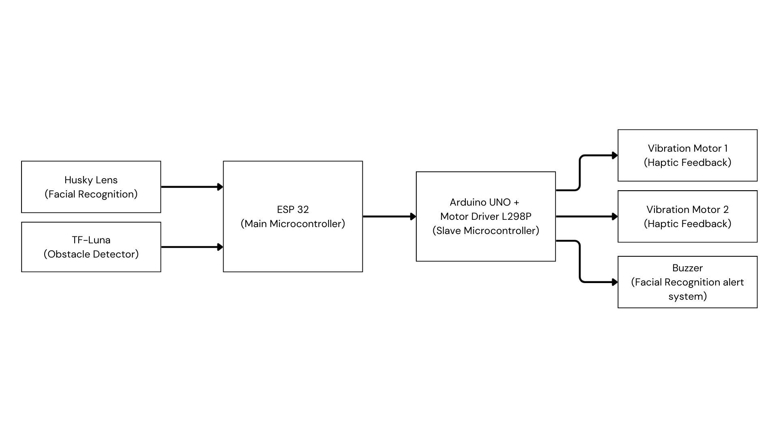
Fig. 1 Block diagram of a system HaptiSense Vest

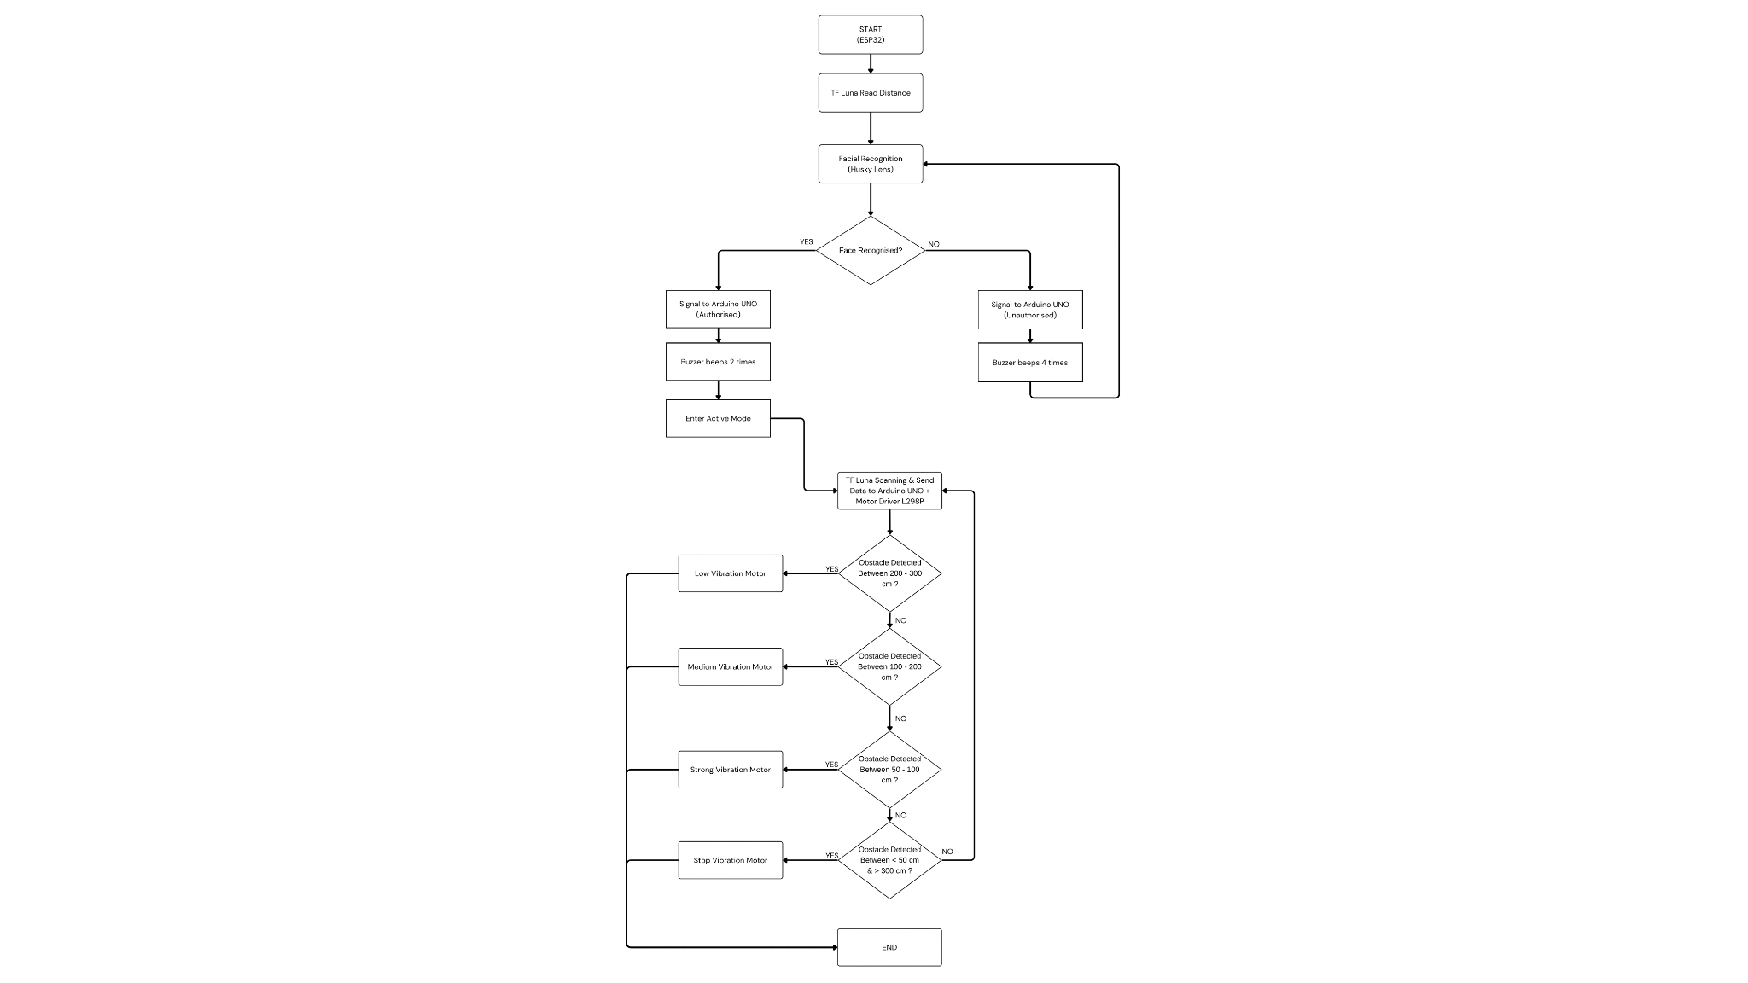
Fig. 2 The flow chart that explains all the work principles for the HaptiSense Vest

2.2 Schematic Diagram and Prototype Setup

Fig. 3 illustrates the circuit diagram of the core obstacle detection and haptic feedback system, which utilizes an ESP32 microcontroller as the primary processing unit integrated with a HuskyLens AI vision sensor for real-time object recognition. The system is powered by a 9V battery source connected to an L298P motor shield stacked onto an Arduino, which serves as the driver for the haptic feedback mechanism. Communication between the ESP32 and the Arduino is established through a shared breadboard interface, allowing the vision system to trigger two independent vibration motors—designated for left and right directional alerts—to provide the user with tangible spatial awareness. This prototype setup in Fig. 4 is designed for a chest-wearable configuration, ensuring the HuskyLens maintains an unobstructed field of view while the dual-motor output delivers intuitive haptic signals to the user upon detecting environmental hazards.
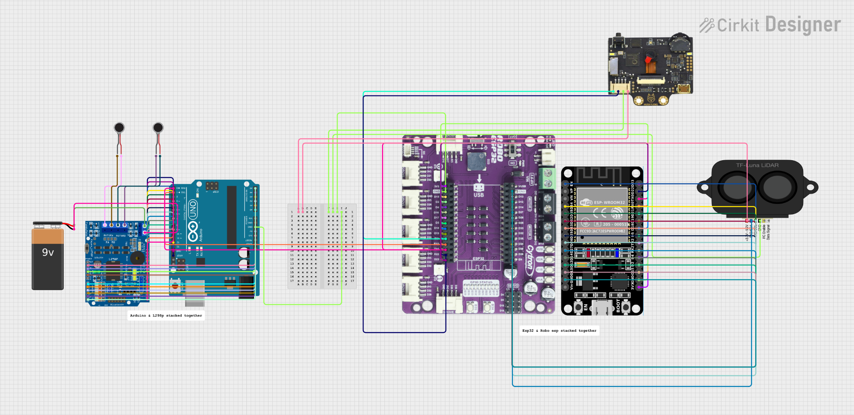
Fig. 3 Wiring Diagram
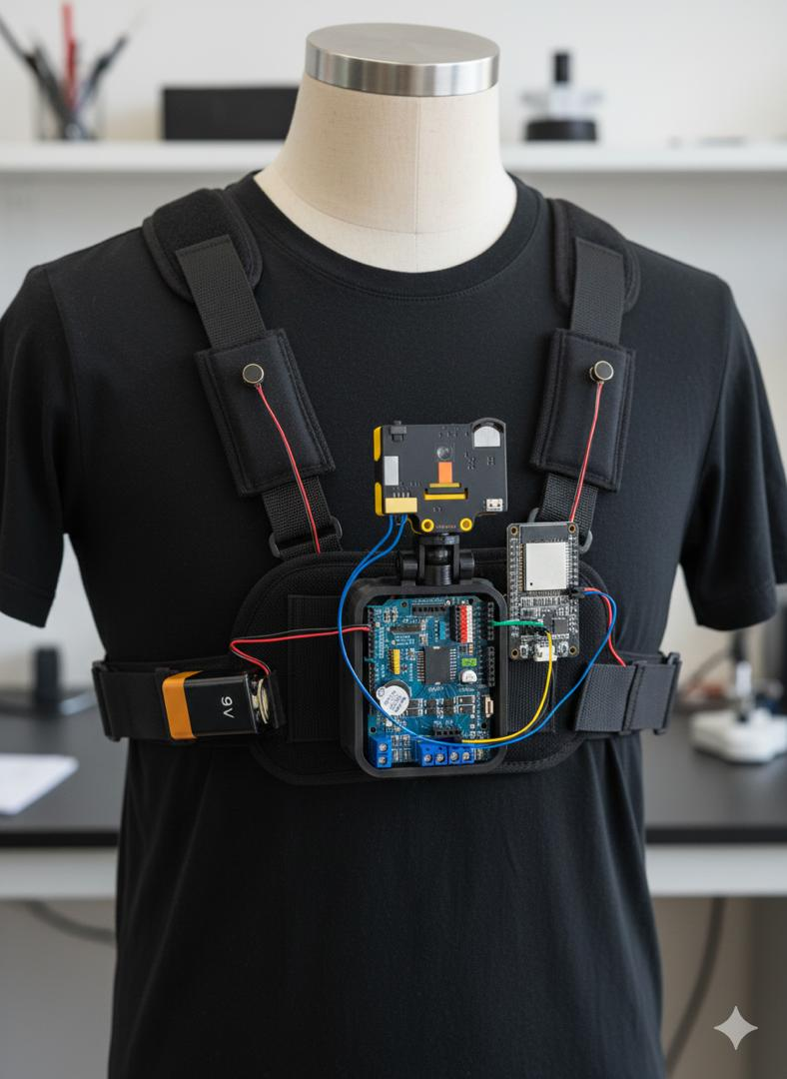

Fig. 4 Prototype Setup (Gemini)

3. RESULT AND DISCUSSION

3.1 Distance-Based Haptic Feedback System Analysis
The distance-based haptic feedback system of the HaptiSense Vest was evaluated to examine the system response to varying obstacle distances. The TF-Luna LiDAR sensor continuously measured the distance of obstacles placed in front of the user. The measured distance data were processed by the ESP32 microcontroller and transmitted to the Arduino Uno only after successful facial recognition authentication. This conditional transmission ensured controlled and secure system operation, preventing unauthorized activation of the haptic feedback system.
Obstacle detection experiments were conducted by positioning objects at predefined distance ranges corresponding to different vibration motor intensity levels. The physical arrangement of obstacles at these distance ranges is illustrated in Fig. 5.1–5.4. These figures represent the experimental setup used to validate the distance-based haptic feedback mechanism.

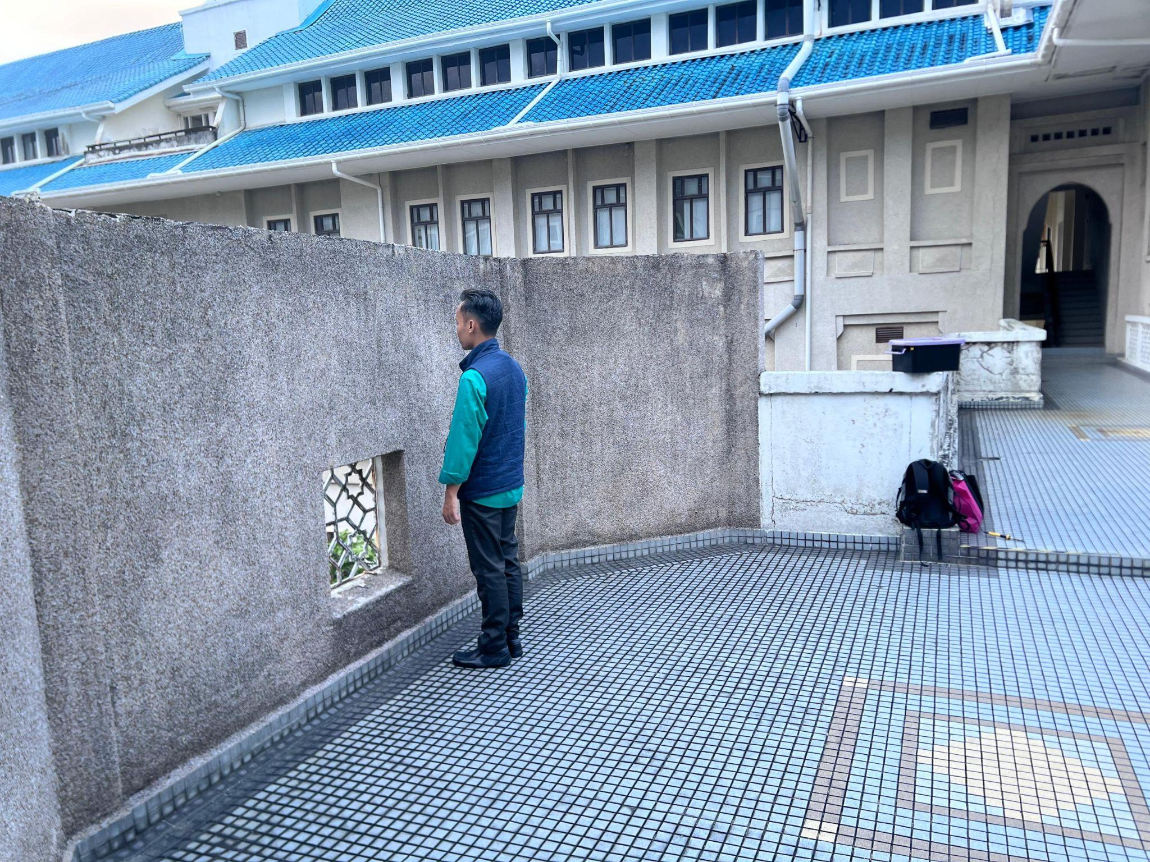
Fig. 5.1 Physical range when vibration motor off
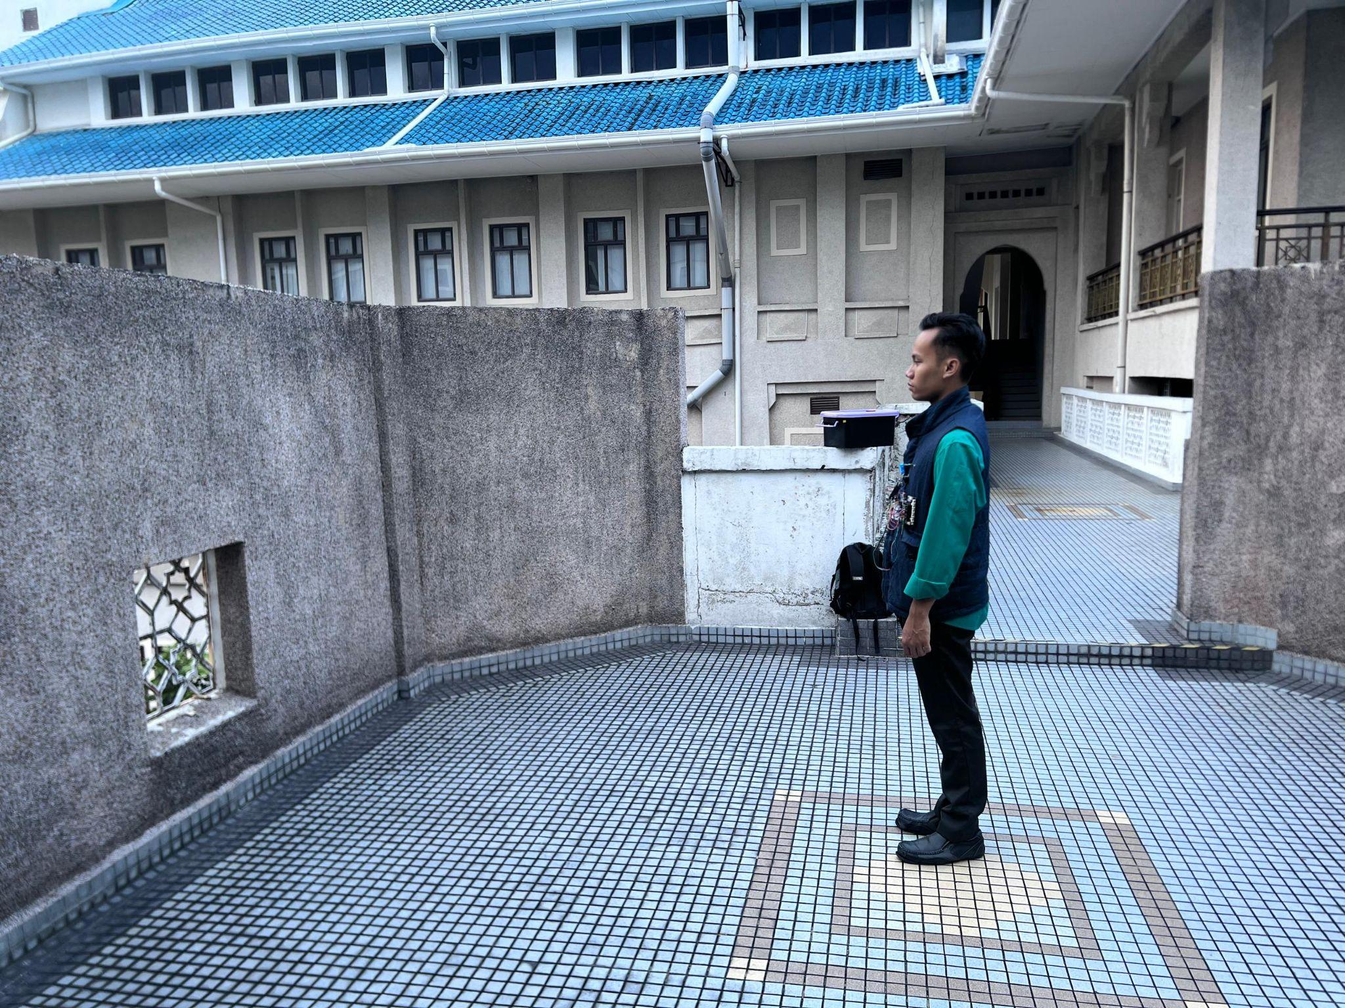
Fig. 5.2 Physical range when vibration motor low

Fig. 5.3 Physical range when vibration motor medium


Fig. 5.4 Physical range when vibration motor strong
To provide a clear summary of the test conditions, Table 2 lists the distance ranges evaluated, the assigned vibration intensity levels, and the corresponding reference figures used during testing.
Table 2 Distance-Based Haptic Feedback Test Conditions
Test No | Distance Range (cm) | Assigned Vibration Level | Reference Figure | Remarks
1 | < 50 or > 300 | Off | Fig. 5.1, Fig 6.1 | Outside effective sensing range
2 | 300 – 200 | Low | Fig. 5.2, Fig 6.2 | Distant obstacle
3 | 200-100 | Medium | Fig. 5.3, Fig 6.3 | Approaching obstacle
4 | 100-50 | Strong | Fig. 5.4, Fig 6.4 | Near Obstacle

The corresponding distance measurements and vibration motor states observed through the Arduino serial monitor are presented in Fig. 6.1–6.4. These outputs confirm correct distance detection, reliable communication between the ESP32 and Arduino Uno, and proper activation of the vibration motors according to the predefined distance thresholds.

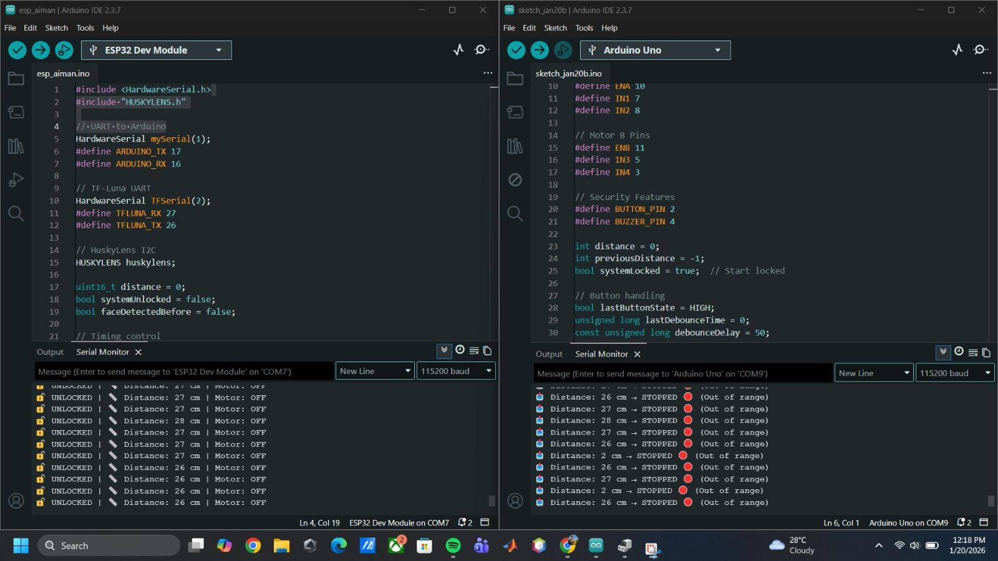
Fig. 6.1 Serial monitor output when vibration motor is OFF.
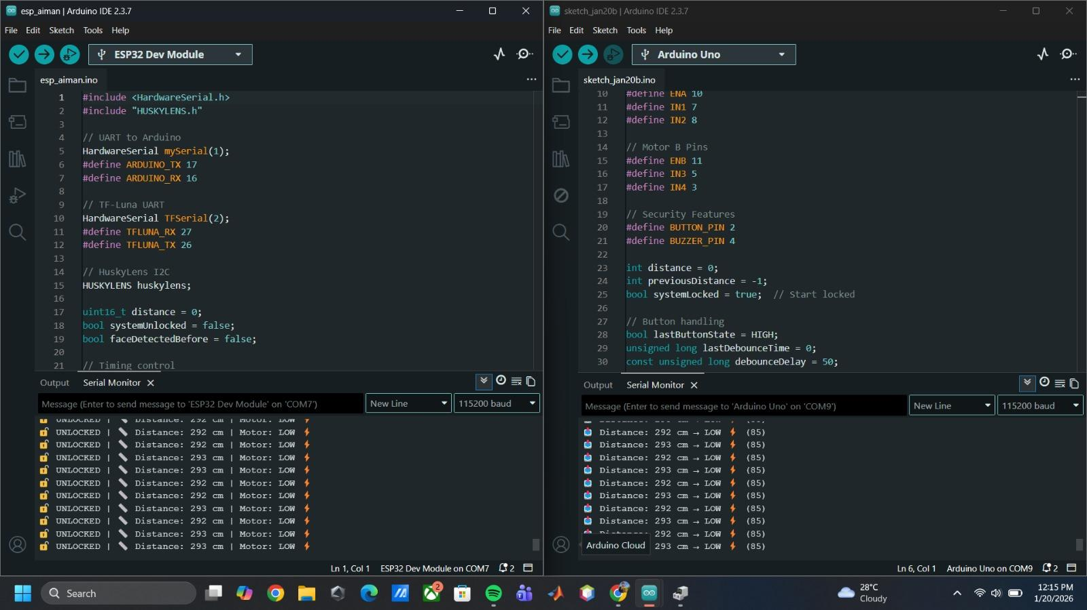
Fig. 6.2 Serial monitor output when low vibration is generated.
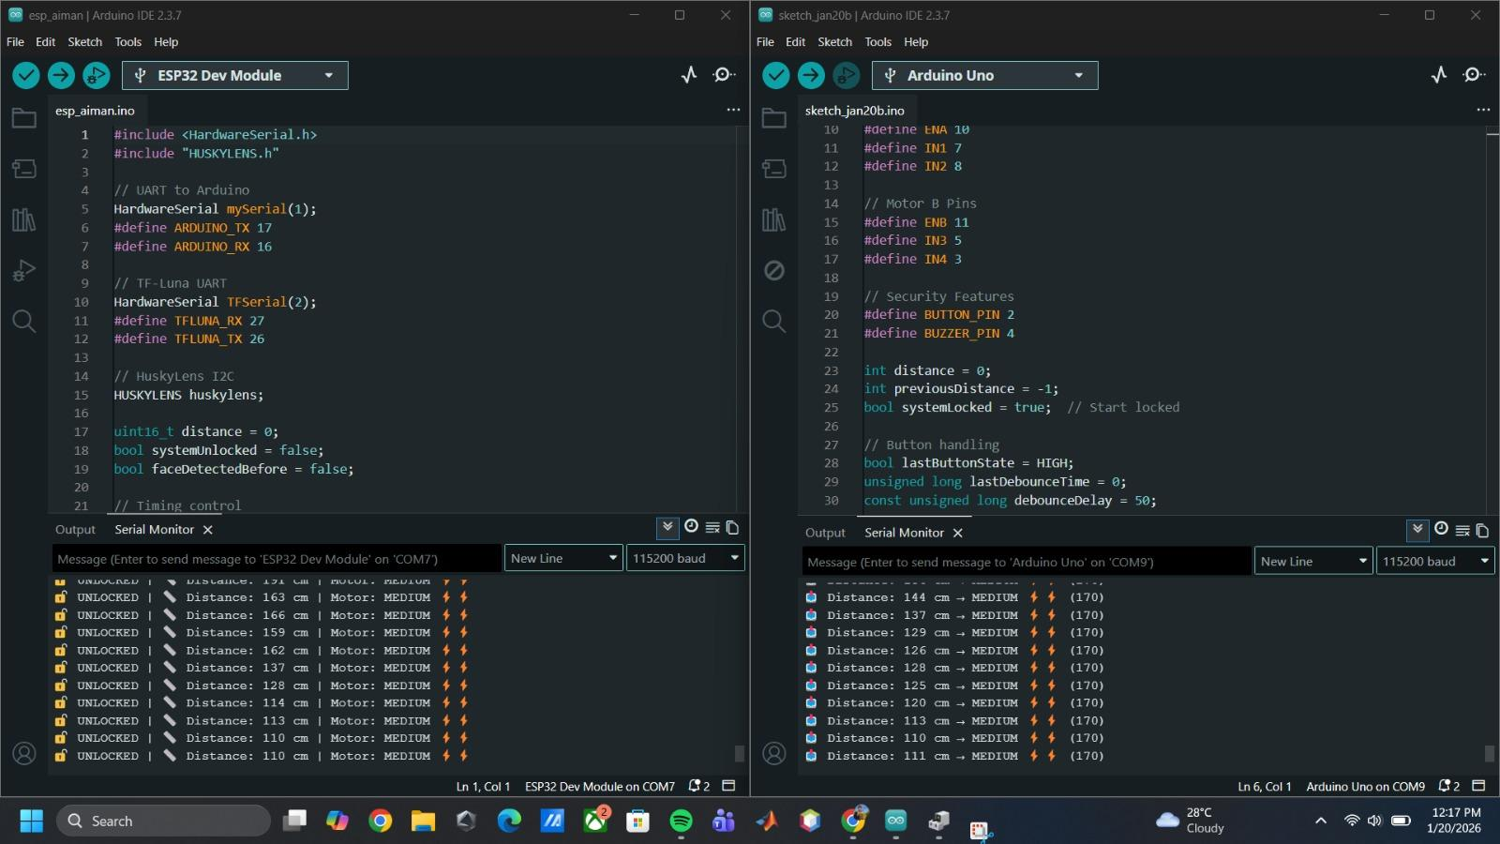
Fig. 6.3 Serial monitor output when medium vibration is generated.
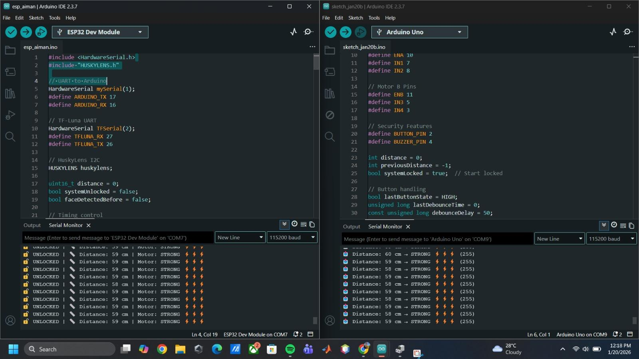
Fig. 6.4 Serial monitor output when strong vibration is generated.
When the detected distance was outside the effective operating range (below 50 cm or above 300 cm), the vibration motors remained inactive, as shown in Fig. 6.1. This behavior prevents unnecessary or misleading haptic feedback. For obstacles located between 300 cm and 200 cm, low-intensity vibration was generated (Fig. 6.2), indicating the presence of distant objects. As the obstacle distance decreased to between 200 cm and 100 cm, medium-intensity vibration feedback was produced (Fig. 6.3). Strong vibration was observed when obstacles were positioned between 100 cm and 50 cm, indicating close proximity and requiring immediate user awareness (Fig. 6.4).
The experimental results demonstrate a clear and progressive relationship between obstacle distance and vibration motor output. The L298P motor driver effectively regulated the power supplied to the vibration motors, enabling distinct and stable haptic feedback levels. Throughout testing, communication between the TF-Luna LiDAR sensor, ESP32 microcontroller, and Arduino Uno remained reliable, as evidenced by consistent serial monitor readings.
Overall, the distance-based haptic feedback system successfully provided intuitive tactile cues corresponding to obstacle proximity. The integration of accurate sensing, real-time processing, and controlled actuation within a structured mechatronics system architecture ensures reliable obstacle awareness without reliance on visual or continuous auditory feedback, making the system suitable for wearable assistive applications for visually impaired users.

3.2 System Facial Recognition
The facial recognition system is integrated as an additional safety and identification feature in the wearable obstacle detection system. The HuskyLens vision sensor is used to perform on-device facial recognition, enabling the system to distinguish between authorized and unauthorized individuals without requiring cloud processing.
During operation, the ESP32 initializes the HuskyLens module and continuously checks for facial input. When a face is detected, the system evaluates whether the face matches a pre-registered identity. If the face is recognized as authorized, a signal is sent to the Arduino UNO, and the buzzer generates two short beeps, indicating successful recognition. The system then proceeds to normal obstacle detection mode.
If the detected face is not recognized, the system classifies it as unauthorized. In this case, the ESP32 sends a different signal to the Arduino UNO, triggering the buzzer to emit four short beeps as a warning alert. The system does not enter active navigation mode until an authorized face is detected, ensuring controlled system usage.
Results from repeated indoor testing demonstrate that the facial recognition system performs reliably under normal lighting conditions. Recognition accuracy remains consistent at close to medium distances, and the audible feedback provides immediate confirmation of recognition status. However, performance is slightly affected under poor lighting or when the face is partially occluded, which is a known limitation of camera-based recognition systems.
Despite these limitations, integrating facial recognition enhances system security and personalization. It allows the wearable device to operate only for registered users and provides a clear alert mechanism when an unrecognized individual is detected.

Table 3 Buzzer Alert Patterns for Facial Recognition Status
Detection Type | Number of Beeps | Meaning
Authorized | 2 | Access granted
Unauthorized | 4 | Warning alert
Table 3 shows the buzzer alert patterns for the facial recognition results. Two buzzer beeps mean that the face is recognized as an authorized user, while four buzzer beeps indicate that the face is not recognized. This simple alert method allows the user to quickly understand the system status without needing visual information.
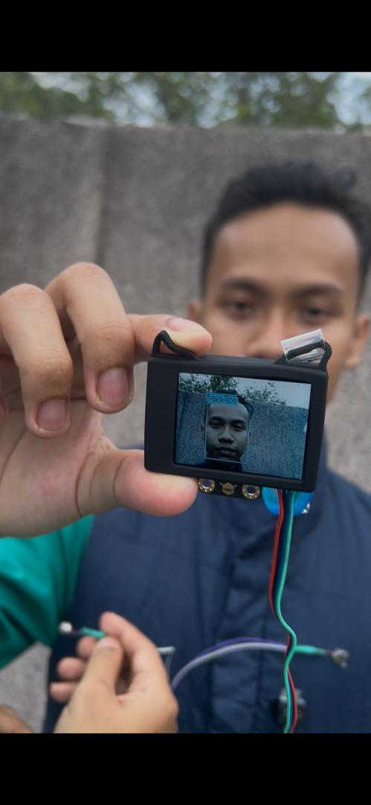
Fig. 7.1 Authorized Face Recognition Result (Face ID 1)
This figure shows an authorized user successfully recognized by the HuskyLens as Face ID 1.
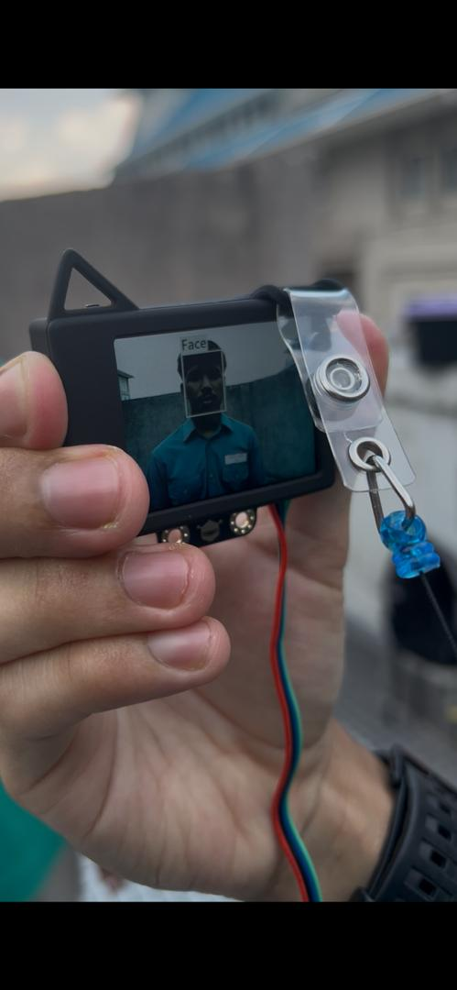
Fig. 7.2 Unauthorized Face Detection Result (No Face ID Assigned)
This figure shows an unauthorized face detected by the HuskyLens, where no face ID is assigned.

4. CONCLUSION
To sum up, HaptiSense Vest has achieved its main goal of creating an easy to wear, small obstacle detection device that will improve the safety and mobility of customers with visual impairments. The system can enable the user to have intuitive and real-time feedback concerning the presence of obstacles around it without needing visual or constant audio signals by incorporating a TF-Luna LiDAR sensor with distance-based haptic feedback. The multi-level vibration feedback is quite effective in relaying the obstacle proximity which enables the user to respond appropriately and navigate their environment in a much safer manner.
The two-microcontroller system, with the ESP32 doing the sensing and decision-making and the Arduino UNO doing the actuation control has been shown to perform reliable system operation, and the response times were high. Accurate distance measurement, stable modulation of vibration intensity, and stable communication between components of the system have been proved through the experimental results. Besides, the HuskyLens facial recognition module will promote the security of the system in terms of controlled use and providing explicit signals of the buzzer to authorized and non-authorized users. The personalization and protection of this feature contribute to the proposed system and makes it superior to traditional wearable assistive devices.
The prototype will have some limitations though it is an effective one such as limited field testing, facial recognition sensitivity to lighting conditions, and relying on battery power. These limitations bring in the possibility of improvement in future. The possible improvements are improving the detection field by adding several LiDAR sensors, adding GPS-based navigation and sharing of emergency locations, adding voice feedback as an option, and rethink the power supply by adding rechargeable or solar-powered energy sources. Moreover, adding adaptive or AI-based learning algorithms may enable the system to modify feedback patterns depending on the behavior of users, and the vest will be more personalized and effective.
Altogether, the HaptiSense Vest shows how embedded systems, sensor integration, and human-centered design can be used in assistive technology in practice. The prototype will offer a good basis on which additional progress can be made towards a more stable, intelligent, and user-friendly wearable mobility aid that can radically enhance the level of independence and quality of life to the visually impaired people.

REFERENCES
[1] A. A. Rahman, M. F. Ismail, and N. A. Hamzah, “Wearable obstacle detection system for visually impaired people using vibration feedback,” International Journal of Advanced Computer Science and Applications, vol. 10, no. 6, pp. 123–129, Jun. 2019. Available: https://www.researchgate.net/publication/334567890
[2] S. Patil and R. R. Karhe, “Smart wearable assistive system for visually impaired using distance sensors and haptic feedback,” International Journal of Engineering Research & Technology, vol. 9, no. 4, pp. 456–461, Apr. 2020. Available: https://www.ijert.org/smart-wearable-assistive-system
[3] D. F. Wolf and G. S. Sukhatme, “Mobile robot simultaneous localization and mapping in dynamic environments,” Autonomous Robots, vol. 19, no. 1, pp. 53–65, Jan. 2005. Available: https://link.springer.com/article/10.1007/s10514-005-0453-7
[4] D. D. Nguyen, H. T. Pham, and T. N. Le, “Face recognition-based access control system using embedded vision sensors,” IEEE International Conference on Consumer Electronics, pp. 1–4, Aug. 2021. doi: https://doi.org/10.1109/icce50685.2021.9427612
[5] S. S. Sahoo, S. Mahapatra, and P. K. Pattnaik, “Wearable assistive system for visually impaired using ultrasonic sensors and vibration feedback,” International Journal of Scientific & Engineering Research, vol. 9, no. 5, May 2018. Available: https://www.ijser.org/researchpaper/Wearable-Assistive-System-for-Visually-Impaired.pdf
[6] A. M. Nada, M. A. Fakhr, and A. F. Seddik, “Assistive navigation system for visually impaired based on depth camera and haptic feedback,” International Journal of Computer Applications, vol. 174, no. 6, Sep. 2017. Available: https://www.researchgate.net/publication/319098456
[7] H. Fernandes, P. Costa, and J. Barroso, “Wearable navigation assistance for visually impaired people using vision and tactile feedback,” Sensors, vol. 19, no. 12, Jun. 2019, Art. no. 2734, doi: https://doi.org/10.3390/s19122734
[8] M. Elmannai and K. Elleithy, “Sensor-based assistive devices for visually impaired people: Current status, challenges, and future directions,” Sensors, vol. 17, no. 3, Mar. 2017, Art. no. 565, doi: https://doi.org/10.3390/s17030565
[9] Y. Li, X. Chen, and Z. Wang, “Real-time face recognition system based on embedded vision platform,” IEEE Access, vol. 8, pp. 18932–18941, Feb. 2020, doi: https://doi.org/10.1109/ACCESS.2020.2968654
[10] DFRobot, “HuskyLens AI vision sensor for face recognition applications,” DFRobot Wiki, Mar. 2021. Available: https://wiki.dfrobot.com/HUSKYLENS_V1.0_SKU_SEN0305

ACKNOWLEDGEMENT
The successful completion of this project and report would not have been possible without the guidance, support, and encouragement provided by our course instructor for the subject Mechatronics System Integration (MCTA3203). Their constructive feedback, clear explanations, and technical insights greatly contributed to our understanding of system integration, embedded systems, and assistive technology design.
We would also like to express our sincere appreciation to the Mechatronics System Integration laboratory staff and teaching assistants for their assistance during the development and testing phases, particularly in providing laboratory facilities, technical support, and guidance in troubleshooting hardware and software issues.
In addition, we are grateful to our group members for their strong teamwork, commitment, and collaborative problem-solving throughout the project. Constructive discussions and mutual support among team members played a vital role in the successful completion of this work.
The collective contributions of all individuals involved have been instrumental in the successful development and documentation of the HaptiSense Vest project.

CONFLICT OF INTEREST
The authors declare that there is no conflict of interest regarding the research, development, and publication of this project. The work was conducted solely for academic purposes and was not influenced by any commercial, financial, or personal relationships that could be perceived as a potential conflict of interest.

AUTHOR CONTRIBUTION
This is to certify that we are responsible for the work submitted in this report, that the original work is our own except as specified in the references and acknowledgement, and that the original work contained herein have not been untaken or done by unspecified sources or persons.
We hereby certify that this report has not been done by only one individual and all of us have contributed to the report. The length of contribution to the reports by each individual is noted within this certificate.
We also hereby certify that we have read and understand the content of the total report and no further improvement on the reports is needed from any of the individual’s contributors to the report.
We therefore, agreed unanimously that this report shall be submitted for marking and this final printed report has been verified by us.

Signature : Aiman
Name : Muhammad Aiman Alfaruq Bin Noredan
Matric number : 2316963
Contributions : Methodology and Result & Discussion

Signature : Hariz
Name : Muhammad Hariz bin Helmi Shamsul
Matric number : 2316441
Contributions : Schematic diagram and prototype setup, conclusion

Signature : syazmieakmal
Name : Wan Syazmie Akmal bin Wan Saad
Matric number : 2316957
Contributions : Introduction and Result & Discussion

